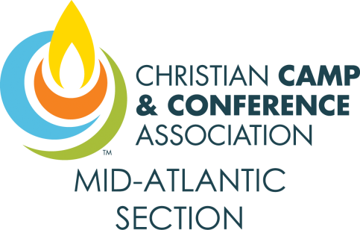

Vendor Code of Conduct

Christian Camps & Conferences serve similar groups who could be considered competitors. However, we all hold the mutual goal of sharing the hope of Christ Jesus. As such we strive to encourage one another and share resources.
As a vendor, you are important to the success of the CCCA Mid-Atlantic Sectional, and play a critical role in servicing our members, whether directly or indirectly. This Vendor Code of Conduct is provided to you as an easy way to communicate our expectations to provide a positive experience for all vendors and sectional attendees. This is a guide and does not include all possible scenarios. We want vendors and attendees to return in the future. Your compliance with these following items will facilitate a healthy partnership with the 3CA Mid-Atlantic Section Cabinet and our Section Members.
- Not every product matches every need.
Your products are quality, that’s why we invited you here. No two camps and conferences are exactly alike so they have varying needs as well. Your product may be a great fit for one camp, but not for another. Be considerate of what other vendors are offering.

- Respect.
When speaking with a potential client, please focus on your products. Respect the customer’s by being honest in the representation of your product(s). Respect what other companies offer by not comparing your product with theirs or pointing out their weaknesses. It is the customer’s role to do the research of each vendor, and to determine how product(s) match their need.
- Professionalism.
Conversations at the Vendor Fair should maintain focus on learning about the needs of the camp/ conference center and how the products you offer can (or cannot) meet those needs.
- Dignity.
Treat each person with dignity. Criticizing a person, group, or product is never necessary.
- Integrity.
You represent the company for which you are a vendor. Leave a positive feeling about your company with each potential customer.

