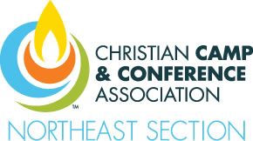

Christian Camp and Conference Association
The 2017 Northeast Sectional Fireside Vendor Lunch: March 14, 2017
The Lodge at Word of Life, Schroon Lake, NY

FAX BACK FORM

Fax to: 603-875-4606
Or Scan and email to: seth@christiancamps.net

Exhibitor (s):

- Will need electricity (120V wall outlet) for simple lighting, TV, VCR, Projector, etc. Not for cooking, heat coils, large motors, nor HVAC equipment. If you have electrical concerns, please be sure note that below.

- Will need a 6’ – 8’ foot folding table provided at the booth (rather than set up a table that you may want moved out of the way, we would like to know if you will be needing a table set up for you.)

- Please attach a 20-30 word description of your services for the program guide.

- Your estimated time of arrival to set up (earliest you can arrive is 10:00 am): _____________
(If you need to come earlier for any reason, please note below)

- Other concerns or arrangements we should discuss to assure a successful event for all.

Company Name: __________________________________________________________
Name(s) of Staff Attending: __________________________________________________
Cell Phone number and Email of Staff Attending: _______________________________
_________________________________________________________________________
Other Information: _________________________________________________________
_________________________________________________________________________
_________________________________________________________________________
_________________________________________________________________________
_________________________________________________________________________
_________________________________________________________________________

